**Summary:**

1. **What continent has the most visited cities in the world?**

Per the heat-map, it shows that Europe has the most visited cities in the world, follow by Asia and then North America.

1. **Can I compare prices across all destination independently of the departure city? What would be the city with the highest price? What would be the city with the lowest price?**

Yes, the bar-plot below shows a trip to Abu Dhabi could cost more than $3500 while a trip to Las Vegas could be for a couple hundred dollars.

1. **Is there a price different selecting two out bounding cities to the same destinations?**

Yes, there is a price difference depending on the cities. For example, flying to Dubai out of Houston the most you will pay is a little over $2500 but if you fly out of Atlanta, the airfare could cost as much as $4000.

In addition, executing an ANOVA test proves that the p-value of the difference in sample mean of the prices between these two cities is significant.

**F_onewayResult(statistic=3.708615771307178, pvalue=0.005870175293385188) < 0.05 Different in sample means is significant**

**ANOVA – Testing Results**

1. **Is there a price difference flying out from another airport and city besides IAH-Houston?**

Yes, there is a difference in price but it depends the city that you select. For example, if you compare the sample mean price between Houston and Atlanta, there is not significant difference between the two cities. However, if you compare the sample mean between Houston and New York, there is significant difference in the sample between the two cities. A p-value table is below to corroborate the conclusion.

**T – Test (Independent Samples) - Results**



1. **What is the average price to all destinations departing from Houston?**

The average price was calculated based on user searches on any departure date in December. The fares include direct and indirect flights. We notice that is extremely expensive to go to Brussels and Stockholm because there no non-stop flight option to these cities and user search are all around the last week of December when tickets prices are usually at the highest price.

1. **Since quotes generated are based on user searches, what are the top searched destination by Houstonians?**

The top destinations from Houstonians are London, Paris, Auckland, Vancouver, Tokyo, Toronto, New York, Orlando, Las Vegas and Dubai. This is based on the total number of flights quotes that the user received during the search.

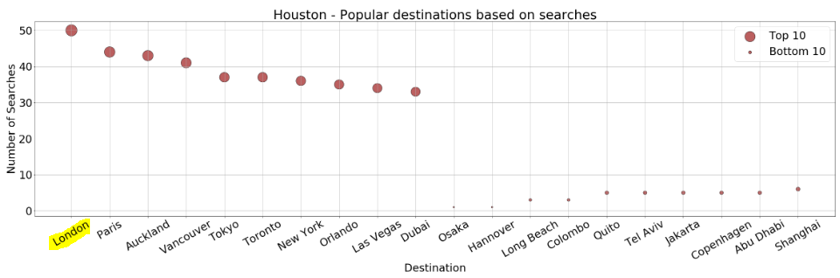

1. **If you flight out of Houston. Is non-stop flight always more expensive?**

By doing an analysis of direct and indirect flight to all destinations, that a couple of key cities, it is cheaper to flight direct, such as Dubai or New York.

Emirates offers A380 non-stop service to Dubai. Routes with connections are mostly thru KLM, British, or Delta. Prices for each segment can add up which end up more expensive in total.

1. Variance = Green bar (direct) - Red bar (Indirect) from the previous slide.
2. Baseline $0 means there’s no difference flying either way.
3. Lower than $0 is the price savings if flying direct.
4. **JFK Airport - Why flying to Providence, RI is so expensive?**

Only 3 searches are available, 2 of which depart on Christmas Eve. The one that cost almost $3,000 is the only non-stop option.

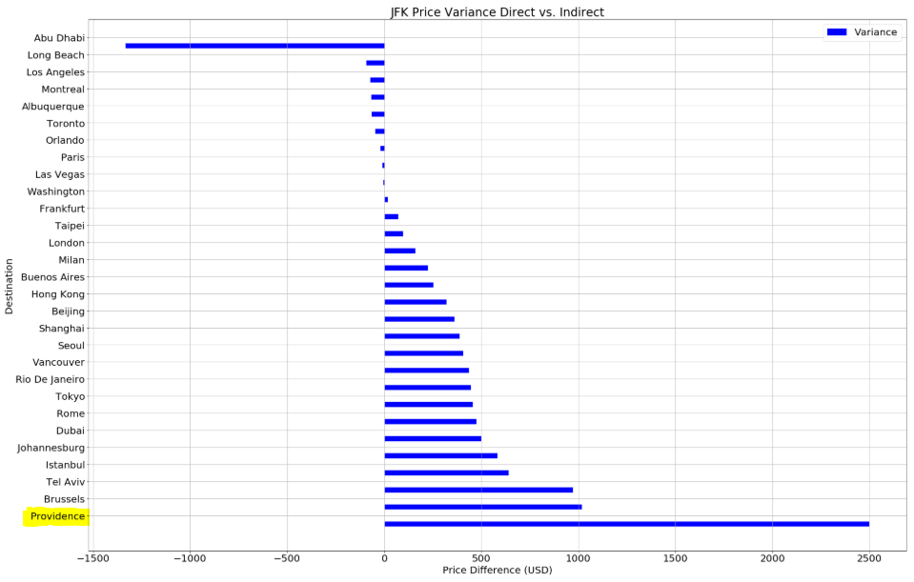



Never heard of “Linear Air”, have you? It is an Air Taxi Aircraft. 

1. **What are the top search destinations in the east and west coast?**

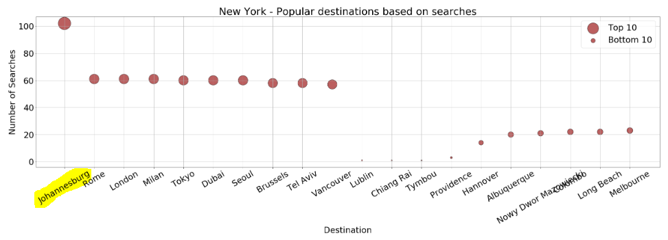

New York:

**1. Johannesburg** – Gateway to Africa

**2. Rome & Milan** – Fashion Capital? Large Italian population?

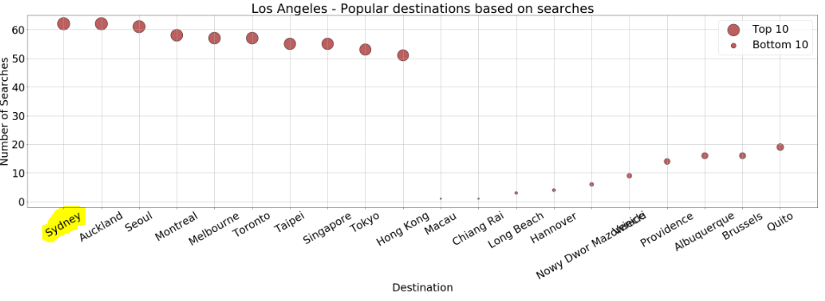

Los Angeles:

**1. Sydney & Auckland** – Gateway to South Pacific. Qantas, Air New Zealand, Virgin Australia offer non-stop flights

**2. Asia** – Gateway to many Asian countries

1. **Flying Direct to Dubai is much cheaper from IAH, but why is it to Abu Dhabi from ORD or JFK ?**

Because there is not a direct flight from Houston to Abu Dhabi. The flights from Abu Dhabi land in New York, Toronto or Chicago.

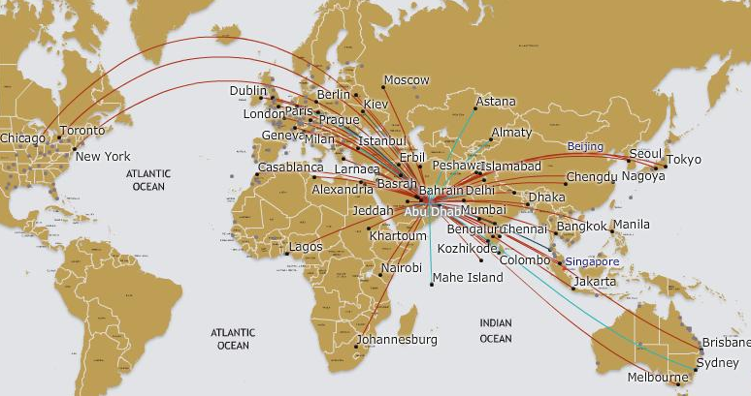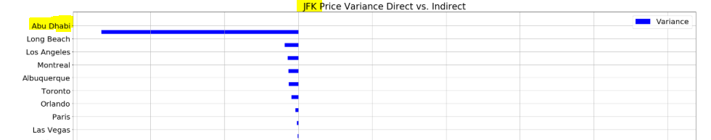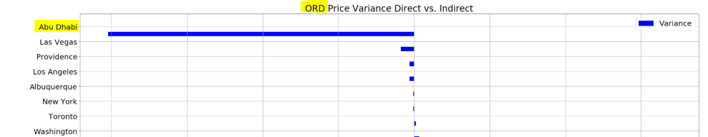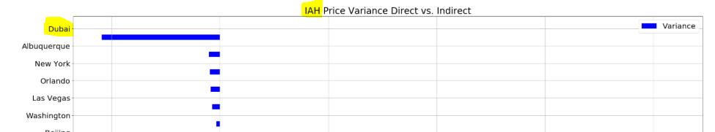

1. **What is the major carrier for both domestic and international out of Houston?**

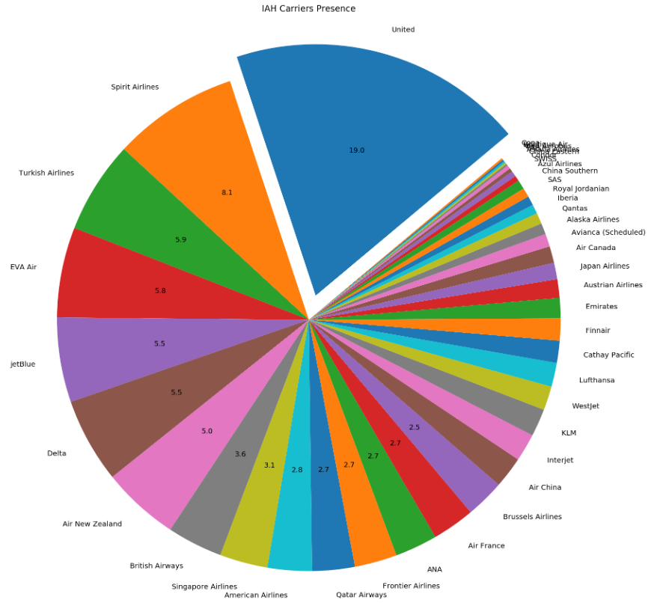United is the major carrier with 19% presence domestic and 32% presence international direct flights.

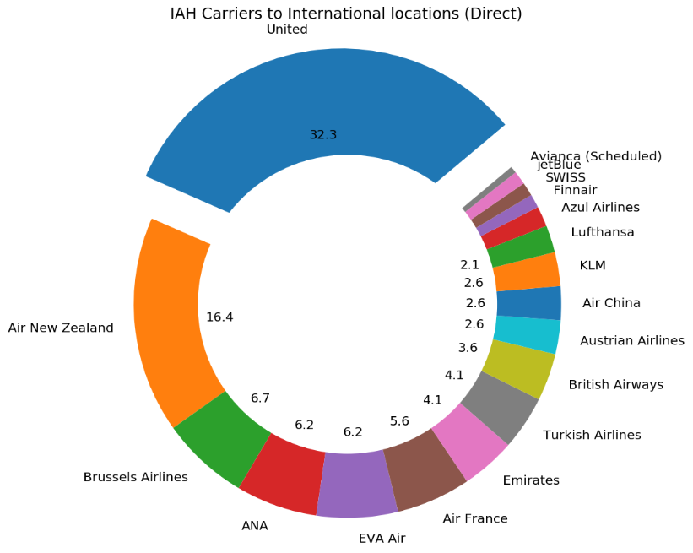

1. **What about for Seattle, what is the major carrier for domestic and international?**

Alaska airlines is the major carrier for domestic, follow by Delta. However, Delta is major carrier for international travels.

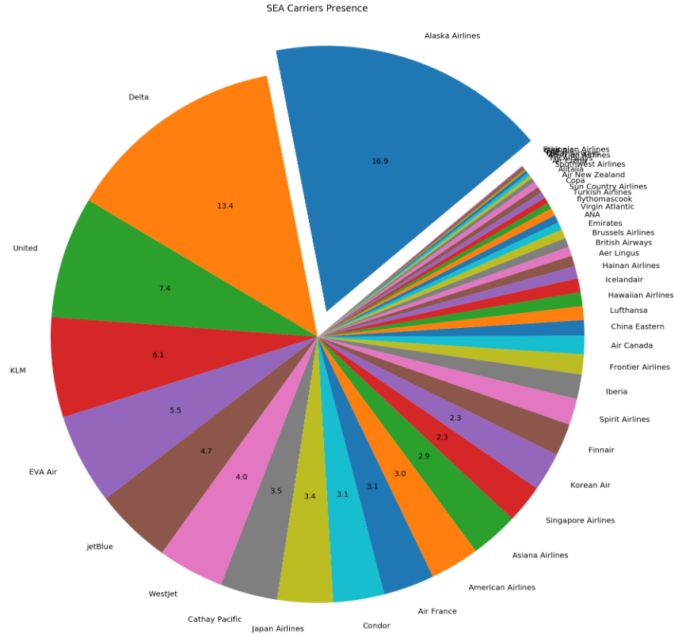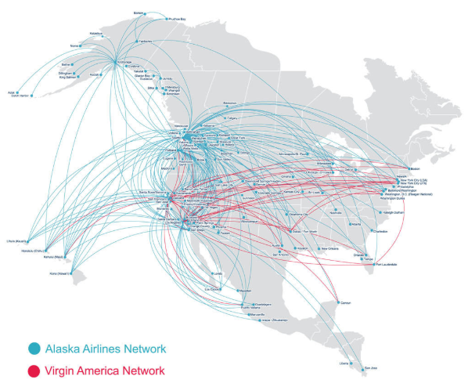**Domestic Flights**

*Not ATL, SEA is the major gateway to Asia for Delta*

**International Presence**

